

*stay in to vote Website*

SOFTWARE PROJECT MANAGEMENT PLAN

Version *<1>*

*04/05/2020*

Nitesh Khakurel

UPDATE HISTORY

|  |  |  |  |  |  |
| --- | --- | --- | --- | --- | --- |
| **Version #** | **Implemented**  **By** | **Revision**  **Date** | **Approved**  **By** | **Approval**  **Date** | **Reason** |

|  |  |  |  |  |  |
| --- | --- | --- | --- | --- | --- |
| 1.0 | Nitesh Khakurel |  | Nitesh Khakurel |  |  |

***Preface***

Due to recent events and the government guidelines to stay in people can not go out and raise awareness about the various key issues. It is not clear when things might go back to normal. This website helps make people aware about the issues and the alternate to in-person voting in case voters want to use it.

TABLE OF CONTENTS

**INTRODUCTION** **3**

PROJECT OVERVIEW 3

PROJECT DELIVERABLES 4

EVOLUTION OF THE SPMP 4

REFERENCE MATERIALS 4

DEFINITIONS AND ACRONYMS 4

**PROJECT ORGANIZATION** **4**

PROCESS MODEL 4

ORGANIZATIONAL STRUCTURE 4

ORGANIZATIONAL INTERFACES 5

PROJECT RESPONSIBILITIES 5

**MANAGERIAL PROCESS** **5**

MANAGEMENT OBJECTIVES AND PRIORITIES 5

ASSUMPTIONS, DEPENDENCIES, AND CONSTRAINTS 5

RISK MANAGEMENT 5

STAFFING PLAN 6

MONITORING AND CONTROLLING MECHANISMS 6

**TECHNICAL PROCESSES** **6**

METHODS, TOOLS, AND TECHNIQUES 6

SOFTWARE DOCUMENTATION 6

PROJECT SUPPORT FUNCTIONS 6

**DESCRIPTION OF WORK PACKAGES** **7**

WORK BREAKDOWN STRUCTURE (WBS) 7

# 

# INTRODUCTION

## PROJECT OVERVIEW

The purpose of the project management plan is to outline necessary steps and procedures for creating software for a Non-Profit organization which works to raise awareness about important issues and encourage people to vote via any acceptable means.

The intended audience of the Stay in to vote Website PMP is all project stakeholders including the project sponsor, senior leadership and the project team.

## PROJECT DELIVERABLES

Due: Monday 5/1 @ 11:59 PM

Final Project Presentation

Due: Monday 5/18 @ 7:00 PM

## EVOLUTION OF THE SPMP

R1.Estimating time & risks - If time is not properly allocated, and deadlines are getting close to being missed and the project contents are rushed, or the deadline is missed all together.

R2.Change of requirements - If the vision of the client changes throughout the project and either changes one of the requirements previously, or adding additional requirements throughout the project life.

R3.Unforeseen circumstances - If any members of the project are unable to complete tasks, someone becomes ill, or drops out of the project all together.

R4.Unclear specifications - Incorrect project initiation, specifications may be unclear and need more details for the project team to complete their tasks.

R5.Neglecting design - Developers may attempt to save time and neglect design. This may cause issues with the traceability, and or functionality of the project.

R6.Technical risks - Changes in technology, and the apparent inability for certain tools to adapt to the project needs may cause a loss of time spent on the project.

## REFERENCE MATERIALS

## DEFINITIONS AND ACRONYMS

SPMP: Software Project Management Plan

SME: Subject Matter Expert

CI: Continuous Integration

# PROJECT ORGANIZATION

## PROCESS MODEL

Agile project management. This model helps to best accommodate the changes in requirements so that the design can be updated accordingly.

## ORGANIZATIONAL STRUCTURE

## ORGANIZATIONAL INTERFACES

Visual Paradigm Online (<https://online.visual-paradigm.com/>) software used to create use cases and WBS.

Hosting services.

## PROJECT RESPONSIBILITIES

This is an individual assignment. So all the responsibilities are handled by Nitesh Khakurel

# MANAGERIAL PROCESS

## MANAGEMENT OBJECTIVES AND PRIORITIES

1. Complete weekly deliverables on time
2. Detailed documentation
3. Simplify tasks and divide work equally through out the semester

## ASSUMPTIONS, DEPENDENCIES, AND CONSTRAINTS

Assumptions:

1. Knowledge from group project will be applicable.
2. All devices and programs will work properly

Dependencies:

1. Website must be updated with relevant articles
2. user interface for website must be created before adding features

Constraints:

Time:

1. Final product due @ Midnight on 5/1/2020
2. Planning goals, delegating tasks, and acquiring equipment/software
3. Scheduling

Scope:

1. Providing clear documentation of progress/changes
2. Managing, reviewing, and implementing changes

Cost:

1. $2.88/month

## RISK MANAGEMENT

R1. Check that all of the projects substance meets to standards and requirements so that the project can make effective use of CI.

R2.Routinely update customers on the status of the project, and ensure that any assumptions that are made are appropriate for the requirements for the project.

R3.Analyze all possible risks that may occur, and ensure that they are prioritized. Ensure all members are aware of these risks, and create contingency plans for these possible risks.

## STAFFING PLAN

Nitesh will run and maintain the project via GitHub.

## MONITORING AND CONTROLLING MECHANISMS

PMP updates, Project documentation update, GitHub commits.

# TECHNICAL PROCESSES

## METHODS, TOOLS, AND TECHNIQUES

Methods:

Agile project management. This model helps to best accommodate the changes in requirements so that the design can be updated accordingly.

Tools:

* Agile
* Wordpress
* Host (namecheap.com)
* Github
* Elementor

Techniques:

* Use php, javascript to create game
* Use HTML (Wordpress) to develop the website
* https://www2.cdc.gov/cdcup/library/templates/cdc_up_project_management_plan_template.doc

## SOFTWARE DOCUMENTATION

All changes will be documented using the Update History form located on page 1. This form will require the developer to fill out detailed information about the changes they have made. The developer must seek approval before the deployment of the updated version. Once approval has been given the developer, as well as the approver, will discuss the changes with the client. Once the client is satisfied with the new update the developer will require them to sign the document located in Appendix A. This will show that all persons of interest have verified and are aware of the new changes being implemented in the project.

## PROJECT SUPPORT FUNCTIONS

Quality assurance:

* Control activities of the project
  + Update history
  + Appendix A
* Peer-to-peer reviews
  + Verify work of an individual is rational and will not crash the system
  + Verify developers have appropriate experience with the tool and techniques being used
* Software Testing
  + Screen for bugs in the system before deployment
  + Deploy beta testing to evaluate user experience and document issues they may encounter

Configuration management plan:

The configuration management plan (CMP) is to document and inform project stakeholders about CMP within a project, what CM tools will be used, and how they will be applied by the project.

Verification and validation plan:

Utilizing the following forms to ensure verification and validation of the project.

* Update History form
* Appendix A form

# DESCRIPTION OF WORK PACKAGES

## WORK BREAKDOWN STRUCTURE (WBS)

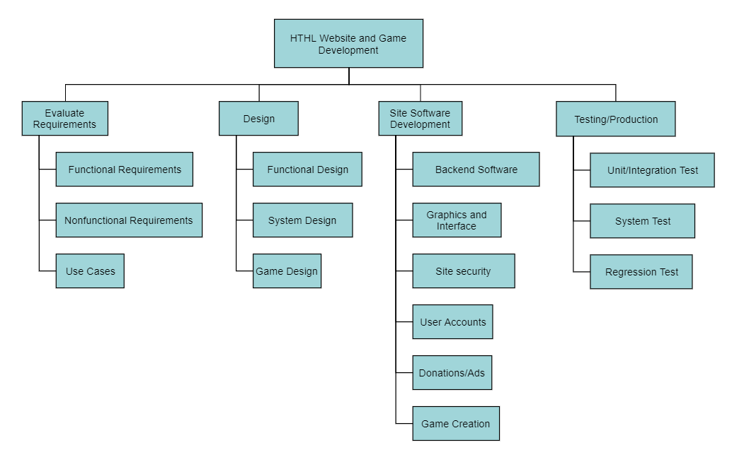

## 5.2 Gantt Chart

**Appendix A: Project Management Plan Approval**

The undersigned acknowledge they have reviewed the DHHS Health Education Website **Project Management Plan** and agree with the approach it presents. Changes to this **Project Management Plan** will be coordinated with and approved by the undersigned or their designated representatives.

|  |  |  |  |
| --- | --- | --- | --- |
| Signature: |  | Date: |  |
| Print Name: |  |  |  |
| Title: |  |  |  |
| Role: |  |  |  |

|  |  |  |  |
| --- | --- | --- | --- |
| Signature: |  | Date: |  |
| Print Name: |  |  |  |
| Title: |  |  |  |
| Role: |  |  |  |

|  |  |  |  |
| --- | --- | --- | --- |
| Signature: |  | Date: |  |
| Print Name: |  |  |  |
| Title: |  |  |  |
| Role: |  |  |  |

**APPENDIX B: REFERENCES**

The following table summarizes the documents referenced in this document.

|  |  |  |
| --- | --- | --- |
| **Document Name and Version** | **Description** | **Location** |
| *<Document Name and Version Number>* | *[Provide description of the document]* | *<URL or Network path where document is located>* |